Requirements Capture Plan

To be able to develop my subcomponent to the best possible standard, I will need to obtain a range of different requirements that will provide me with enough information on developing a subcomponent of the web system that allows registered users to create, edit, delete and archive events. Users can create events which can include reviews where a user can publish their viewpoints and opinions with other users in which they can offer recommendations. User can delete their currents events whenever they like, users can edit current events if they wish to modify their reviews because of a change of opinion or they may have made a mistake e.g. spelling and grammar errors etc. This document will walk through the different types of methods that will be used to help obtain useful requirements for creating the system.

Questionnaire

One document that I will use to help gain requirements is a questionnaire document, by using a questionnaire document I can find out the views and opinions from users about our system, they could be asked to rank from 1 to 10 (1 being the least and 10 being the highest) on how interested they are in our product and how likely they are to visit our website. Any users who confirm they have a definite interest in using our product may be asked about what their expectations are and what features they would like to see that are not currently within the system. For example, “Would you like the events page to display a map showing the reviewed locations” or “Would you like to see feedback only displayed in text form”. Whilst creating this document it will be important to keep certain things in mind in order to create an effective questionnaire. One aspect that will be important is to keep the questionnaire as short as possible or to at least make it possible to complete the questionnaire in the shortest amount of time. By doing this it will be beneficial towards people who are completing the questionnaire as they will most likely complete it with satisfaction and with honesty (1). If the questionnaire was created in a manner in which there were far too many questions than necessary or if the reader felt it was hugely time consuming, this will bring some negative impacts such as the reader feeling bored and/or frustrated with the document in which they may partially complete the document or may provide answers that are not genuine just to speed up the process.

Furthermore, another aspect of the questionnaire that is equally important is the overall quality of the questions. Whilst creating this document it will be important to take our time and to create a series of high quality questions that not only benefits the reader but will also benefit the group and our system. By asking questions of high quality and is relevant to our project will bring its fair share of advantages as we will be able to extract useful feedback and opinions from our users which will help in the long term when developing my “create an event” webpage as I will be informed of what our target audience would like to see and their expectations (Requirements Techniques, 2018). If the questions are poorly designed and are not relevant to the specified system/sub component then this will simply provide poor and useless information which will not give me a better idea on how to effectively layout the subcomponent. It will also frustrate our target audience as they will feel as if they are wasting their time if the questionnaire is not up to a high standard and if their expectations have not been met with satisfaction.

Existing systems

Analysing existing systems is great method to gain new requirements for a system as by observing current systems which have similar purposes, this will help me in identifying important and relevant requirements that I can utilise within my own subcomponent of the web system. However, when looking at current systems which may perform similar roles it is important to ensure I must only take ideas from these systems and not to completely replicate functionalities of these web systems as the subcomponent I will be creating for my system will be different compared to systems which are already on the market and the target audience I am appealing to will be different compared to the target audiences of other organisations. Therefore I will need to be careful of the types of requirements I extract from other systems as I want to prevent creating a subcomponent that does not meet or satisfy the expectations of the target audience.

Brainstorming Ideas

Another method that will be used to obtain useful requirements for my system will be the concept of brainstorming a range of different ideas. Through the use of brainstorming, this can be a powerful way to develop new ideas for the system and in particular my subcomponent as the entire group can engage with each other and consider all types of scenarios that can possibly occur with this system, group members can consider different ‘what if’ scenarios where we can discuss what might occur if I design the subcomponent in a specific way and what impacts can occur from my decision making (Inflectra, 2018). With brainstorming this can be implemented in a number of ways such as having a face to face discussion with other group members where we can exchange different opinions or I can create a word document where I can write down all of my ideas and also the ideas of my group members where I can review and analyse each idea/viewpoint and decide which ones I should take on board and which ones I should avoid. By encouraging other members to provide me with their viewpoints it will help to broaden my mind to fresh alternatives I may not have considered initially.

In addition, another advantage of brainstorming will allow me to look at my own design from an objective and critical point of view without being influenced by any biases I may have. By allowing myself to think more critically I will be more likely to approach a problem and solve it in a logical and effective way, it will allow me to possibly break my subcomponent down into different sections where I can revaluate my designs and features that I have implemented and to hopefully come to a conclusion on whether I should maintain or remove the ideas that have been brought up (Price K, 2019).

Requirements Analysis

Current Systems

Travello

In terms of the current systems available on the market that are similar to the system I am designing. One example of a system that is similar is an app called ‘Travello’ which is essentially a social network for users who are travellers and can meet up and engage with other travellers. With this app users can:

* Find other travellers who are nearby and can join up with (Travello, 2018)
* Post their photos and travel updates on a social feed, whilst also being able to interact with other users (Travello, 2018).
* Users of the app can join groups of other travellers who share similar interests (Travello, 2018).
* Find travellers who will be in the same location at a specific time (Travello, 2018).
* Find out the best travel deals worldwide (Travello, 2018).
* A global map which contains points of interest, things to do etc. (Travello, 2018)

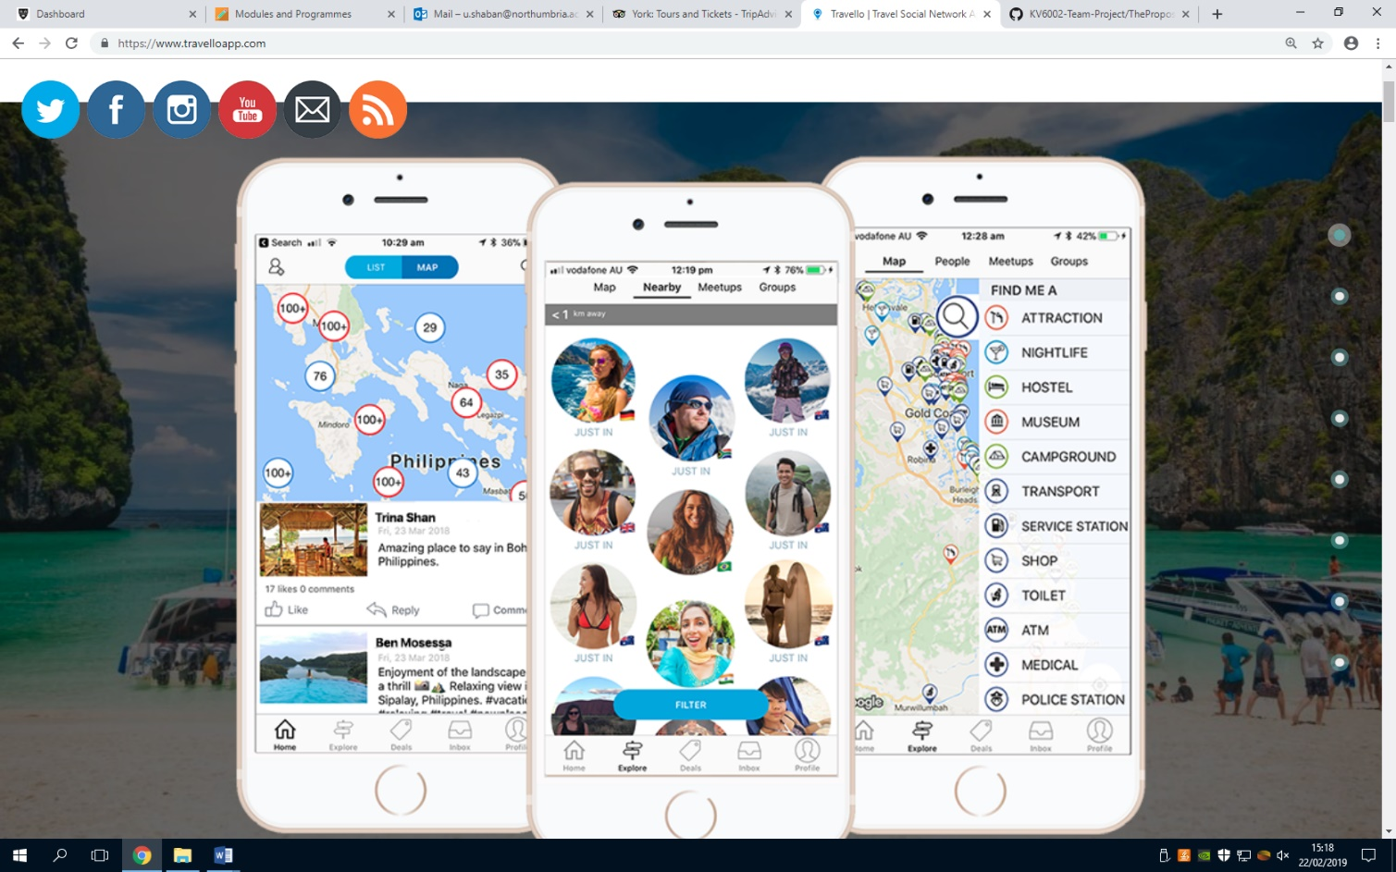

Figure 1: The image above shows the design and user interface of the mobile app.

Based on the design of the app and the features that it contains, this app has an appealing and professional appearance which can attract first time users to install this app on their IOS or Android devices based on first impressions. The user interface of this app looks attractive and of high quality which will persuade users to think this app was developed by experts and not by amateurs, this app has some interesting features that were mentioned earlier which are similar to the features I aim to implement into the system. One of the features of this app that is interesting and similar to the subcomponent I am involved in creating is the “Users of the group can join groups of other travellers who share similar interests“ feature which is something I could potentially implement in my ‘create an event’ subsystem as the purpose of the web-based system is to attract users to register and collaborate with other travellers. This is an intriguing feature I could use as a temple for my event creation component although it will be crucial to make certain changes to this feature to make it uniquely different.

Another interesting feature from this mobile app is the “A global map which contains points of interest, things to do etc.” feature. This is another functionality that I could potentially use within the create an event design where a registered member of the website can create a brand-new event and then possibly include a map which will display the exact destination, what activities can be done in that location etc. there are a range of different things I could include to meet the needs of the target audience. Overall this mobile app which has been created to specifically target users who enjoy travelling has been useful in providing me with new ideas of what to implement in my subcomponent as the purpose and functionalities are similar to my own system. However, it is important to note that one major difference between this app and the system I aim to complete is that the ‘travello’ system is based purely on a mobile app whereas the system I am involved in developing will be an online web-based system and will not be compatible with mobile devices. So as a result, certain elements will be completely different from this mobile app in terms of screen resolution, screen size, user interface, font size, image sizes etc.

Backpackr

Another example of an existing system which has a familiar system is a mobile app called ‘Backpackr’ which is an app that allows users to find other travel buddies and connect with other travellers around the world, this app allows users to other travellers who share similar interests, who travel to the same locations, and share photos with friends (Backpackr, 2017). The Backpackr app includes a ‘Backpackr Community’ in which users can submit their opinions about the locations they have visited through online reviews, the app also includes a ‘Common Room’ where users of the app can search for nearby posts or can search for a certain country using keywords or hashtags (Backpackr, 2017).

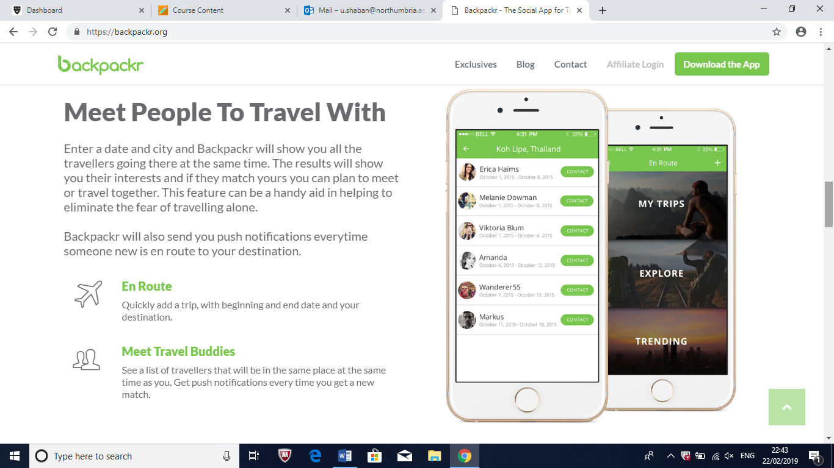

Figure 2: this image shows the designs and the user interface of the app

Just like the previous app I mentioned, this traveller’s app looks to have been designed professionally and to a high standard as the style/theme of the app is consistent and it has a creative display. Just like the previous app this app also shares similar functions with a couple of different features such as being able to post online reviews about visited destinations and that the app allows users to search for nearby posts with keywords/hashtags. This app is also compatible with both IOS and Android so that all users of mobile devices have an opportunity to install this app on their smartphone.

The feature that involves being able to search for nearby posts with keywords or hashtags is an interesting functionality which I may possibly use within my own subcomponent which can help improve the overall quality of the web system as the users of our system will have a variety of functionalities at their disposal. Although I will need to be certain the target audience would be satisfied with this feature if it was implemented or if the target audience will feel it is unnecessary to have this feature in the system, I can find out if users would be interested in this by using questionnaires, interviews etc. Furthermore, another useful feature of this app is users can post online reviews about the locations they have travelled to. This is a feature I intend to use in my subcomponent as I want registered users to be able to provide feedback on their destinations and to share their opinions with other users of the site. I will intend to make different changes to my version of the review system by using a star rating out of 5 or a rating out of 10, the comment box may possibly include a word limit restriction to prevent the text from taking up too much physical space of the webpage etc.

Stakeholders

* Project Supervisor
* Members of staff
* Group members
* Consumers
* Users who have an interest in travelling
* Organisations who have developed and provided similar systems (Lagreca, 2018).

References

Requirements Techniques. (2018). *Questionnaire*. [online] Available at: https://requirementstechniques.wordpress.com/elicitation/questionnaire/ [Accessed 18 Feb. 2019].

Inflectra.com. (2018). *Requirements Gathering*. [online] Available at: https://www.inflectra.com/ideas/topic/requirements-gathering.aspx [Accessed 18 Feb. 2019].

Price, K. (2019). *The Importance of Brainstorming*. [online] Smallbusiness.chron.com. Available at: https://smallbusiness.chron.com/importance-brainstorming-77488.html [Accessed 19 Feb. 2019].

Travello | Travel Social Network App | Meet Travellers Nearby. (2018). *Travello | The Social Network App For Travellers*. [online] Available at: https://www.travelloapp.com/ [Accessed 19 Feb. 2019].

Backpackr.org. (2017). *Backpackr - The Social App for Travellers | Find a Travel Buddy*. [online] Available at: https://backpackr.org/ [Accessed 20 Feb. 2019].

Lagreca, K. (2018). *How To Identify Stakeholders For Your Website Project*. [online] Npgroup.net. Available at: https://www.npgroup.net/blog/how-to-identify-stakeholders-for-your-website-project/ [Accessed 21 Feb. 2019].